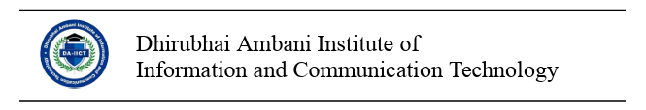
INSTITUTIONAL REVIEW BOARD APPLICATION FORM TEMPLATE
Note: Researchers applying for IRB approval should prepare a document containing the information asked for in the below format. Not all information asked for in the form may be relevant to a particular project, in which case, the principal investigator may skip certain form heads; however, he/she must make sure to be as thorough as possible in details.
The duly filled and signed application should then be sent for approval to the IRB.

- Basic Details about the Investigator/s
1. TITLE
2. PRINCIPAL INVESTIGATOR
3. CO-PRINCIPAL INVESTIGATOR (S)
4. ADDRESS
5. PHONE
6. EMAIL
7. DESIGNATION OF THE PRINCIPAL INVESTIGATOR

- Basic Details about the Project
1. A BRIEF DESCRIPTION OF THE RESEARCH
2. DURATION
3. REVIEW CATEGORY: 1) EXEMPTED; 2) EXPEDITED; 3) FULL

- Complete Details of Research Methodology Adopted.
- ALL RELEVANT DETAILS ABOUT THE HUMAN SUBJECTS INVOLVED IN RESEARCH
(For example, age, sex, demography, education, nationality, disability status, employment, financial status, etc, as applicable)
NOTE: The Board may solicit more information or clarification if necessary.
- DESCRIBE THE DATA COLLECTION PROTOCOL NORMS AND PROCEDURES AS APPLICABLE TO PARTICIPANTS
(For example, participant recruitment & compensation details, consent acquisition, confidentiality norms, information provided to the subjects)
If the research requires that written consent be obtained from the participants, please use the consent form appended.
- RESEARCH GOALS & METHODOLOGY
  - Write briefly about the PURPOSE and SCOPE of the research.
  - Data collection methods:(fieldwork, ethnography, participant observation, internet-based research, questionnaires, audio/video recordings, participant observation etc)
- ENUMERATE THE ADDITIONAL RISKS INVOLVED, IF ANY.

- MEASURES UNDERTAKEN TO MITIGATE RISKS AND THEIR FALLOUT

- FUNDING INFORMATION
(Details about the funding agency, amount, duration etc)

- PRINCIPAL INVESTIGATOR’S ASSURANCE
I hereby certify that the information provided here is accurate and complete to the best of my knowledge. I will abide by the review committee’s recommendations. I further assure that the participants’ rights will be protected from any harm or risk or loss of confidentiality. All changes done to research subsequent to this application are further liable to be approved by the board.

