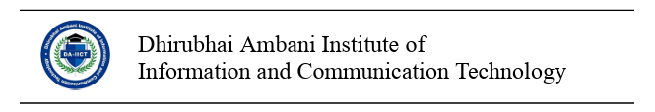

CONSENT FOR PARTICIPATION IN A RESEARCH STUDY
Any participant should sign only after ascertaining that the details mentioned below are explained to him satisfactorily. For online studies, the specified details must be included in the privacy policy of the online platform before the study starts.
Title of the Study:
Principal Investigator:
You can contact the study investigator if you have any questions about the study, concerns or complaints. Contact Principal Investigator
Funding Source:

Information to the Participant:
- Explain the rationale and purpose of the research.
- Indicate why the potential participant is being asked to participate.
- Give a step-by-step guide to the procedures followed.
- Indicate the expected length of the subject’s participation.
- Explain reimbursement procedures
Potential Risks & Benefits
- Explain risks, if any, that could potentially cause damage or discomfort to the participants. For. example:
  - Data collected in this study may be stored and shared for future research in a de-identified fashion. It would not be possible for future researchers to identify you. This can be done without again seeking your consent in the future, as permitted by law.
  - You must be at least 18 years old to participate. If you are not 18 or older, please inform the researcher and do not complete the survey.
  - Explain preventive and safety measures taken to protect the confidentiality and privacy rights of the participants.
  - Indicate the benefits to the participants, if any, for taking part in this study
Confidentiality and Privacy
- Specify briefly the procedures (e.g., coding of research data, storage of linkage code information in separate locked files, firewalls) that will be used to protect the confidentiality of the research subjects.
- Specify the procedures followed to make the participants identity anonymous.
- Address the concerns, if any, about the potential risks to participants once the results are shared with professional and non-professional fora like conferences, classrooms, news media etc.
Withdrawal from Participation
- Information to be shared with the participant regarding his/her withdrawal from the study.
(You can withdraw from this study at any time. Any identifiable data obtained as part of this study prior to the date that you withdrew your consent will continue to be used by the investigators for their research purposes. If you want to withdraw, notify the study team. Your decision to withdraw will have no effect on your current or future relationship with DA-IICT)
Participant Rights
Explain the rights the participant has. (This is purely a voluntary activity. The participant is free to decline to take part in any activity that he/she deems inappropriate for him/her. In case of any ill treatment or misdemeanor or any untoward behavior during the research activity, the participant can inform the principal investigator through email or in person.)

Consent to Participate
(This may be customized if necessary)
This research has been reviewed by the Institutional Review Board (IRB). The above information has been explained to me to my satisfaction. I understand that I am encouraged to ask questions, voice concerns or complaints about any part of this research study during this study. By signing this form, I consent to participate in this research study _______________; and indicate that I have understood what this study is about.
A copy of this consent form will be given to me.
Name of the Participant
___________________________________
Signature of Participant

